DSpace SPbU Repository User Manual

Content
What is DSpace? ......................................................................................................................................................2

DSpace SPbU Communities and Collections .........................................................................................................................2

Browsing DSpace SPbU.................................................................................................................................................2

Authors’ Access to DSpace SPbU ................................................................................................................................4

Adding a Submission to DSpace SPbU ........................................................................................................................5

Step 1. Describe ......................................................................................................................................................6

Step 2. Describe (continued) …………………..............................................................................................................9

Step 3. Upload a File ... ..........................................................................................................................................11

Step 4. Verify Submission …..................................................................................................................................12

Step 5. Distribution License …..………................................................................................................................13

Step 6. Submission Complete ………….............................................................................................................. 14

Additional Information ……………….............................................................................................................................15

1

What is DSpace?
DSpace is an institutional repository platform that collects, distributes and preserves digital material.
DSpace SPbU Communities and Collections
The DSpace open access archive (repository) of St. Petersburg State University contains subject sections (Communities), subsections (Sub-Communities) and collections (Collections) with different kinds of documents.

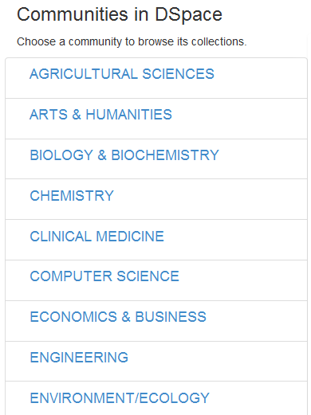

The home page of the repository contains the Discover section with the information on the most published authors and keywords used.

Browsing in DSpace SPbU

Searching and viewing documents is available for all users (with or without authorization) through the Browse panel. You can browse the documents, using the following parameters:
• By subject sections and collections (Communities & Collections);
• By publication dates (Issue Date), chronologically in ascending or descending order;
• By author names (Author), alphabetically in ascending or descending order;
• By publication titles (Titles), alphabetically in ascending or descending order;
• By keywords (Subjects).

Activating the Search DSpace field enables contextual search, including the texts of attached files, abstracts and publication titles.

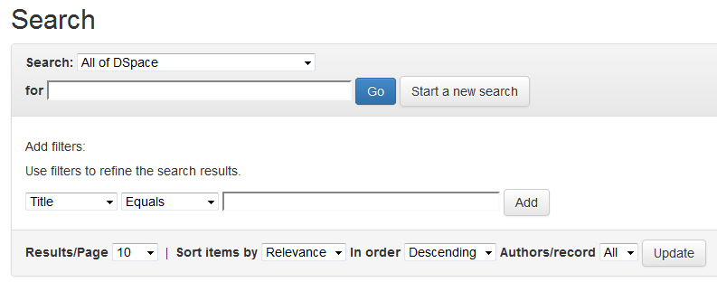
You can use a combination of field and attribute filters by specifying your search options in the Search DSpace field: descending/ascending order, results per page, using data operands (for instance, Contains, Equals, etc.). Search parameters can be changed using the Update function.

2

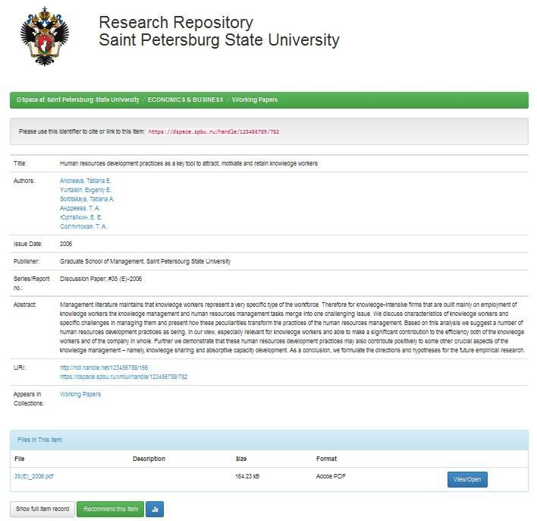
For viewing the publication, you need to select the required title from the list.

There are two modes for viewing the record of a publication – Simple Item Record and Full Item Record. The main language for data presentation in the repository is English.
The Statistics field provides information on the visiting statistics, file downloads and viewing figures for a particular publication.

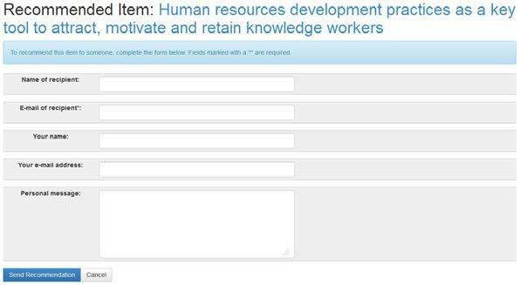
A publication can be recommended to other users with the help of the Recommend This Item function:

Records of the documents placed in the repository are made in English, with the main fields mirrored in the original language of the publication.

3

Authors’ Access to DSpace SPbU

You can work with the DSpace SPbU system as an author if you want:

• To submit documents and related records to collections;
• To subscribe to receive alerts of new items added to collections;
• To edit your profile (change the password and other details) and the information about your publications.

Submission of data to DSpace is only available for affiliated persons – members of the SPbU teaching staff and other SPbU employees. To sign in to the system, you should go to the My DSpace page and enter your login and password, using the corporate access link Enter LDAP Netid and Password.

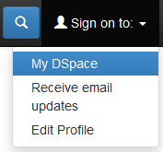
Registration is not required for browsing DSpace SPbU for information.

You can subscribe to receive alerts of new items added to the repository using the RSS subscription service.

You can leave your comments on the work of the repository using the feedback form: Feedback.

To receive or restore your login details (login and password), you need to contact members of the technical support staff for subject sections at the IT SPbU or the Technical Support Department at the Rector’s Office, tel.: 326 4990, e-mail: support@spbu.ru.

4

Adding a Submission to DSpace SPbU

In order to submit documents to the repository, users need to sign in to their account (see Authors’ Access to DSpace SPbU).

The process of adding a new item to DSpace requires filling in dedicated fields with the information (metadata) about the document, as well as uploading full-text files (if available).

In order to enter new information, you need to choose from the following items:
1. Community;
2. Sub-community;
3. Collection;
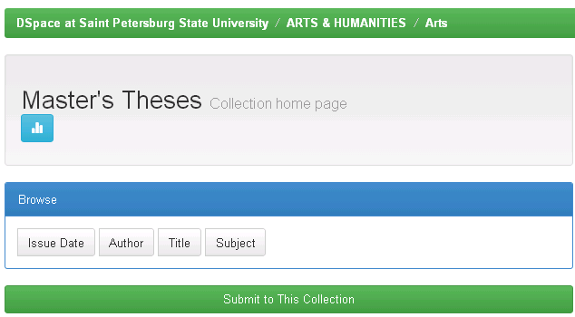
4. Submit to this Collection.

For instance, if you want to add an arts master’s thesis, you need to select the ARTS & HUMANITIES subject area, then the Arts subsection and the Master’s Theses collection inside it. Next, you can proceed to adding information and uploading a full-text file if available.

You can also add a new item to any collection using the Start a New Submission button from My DSpace page.

5

After choosing the collection, you can select the method of adding the publication to the collection: by manual submission (in the manner described below) or by importing metadata using unique publication identifiers (DOI, PubMediD, etc.).

When using the second method (preferable), you need to select the “Search for identifier” item of the menu, enter the unique identifier in the corresponding field and press “Search”.

New submission: get data from bibliographic external service

Default mode Submission

Select collections: ENGINEERING > lnstruments & lnstrumentat1on > Art1cles

Seoнch for identifier

• Uplood • filo

Manual subm1ssю

Exit

Goto
OSpace Home
Му DSpace

New submission: get data from bibliographic external service

• Default modo Submission

Search for identifier

Flll in puЬ11catюn ident1f1ers (DOI 1s preferaЬie) and then press ·search"_ А \1st of all matchюg puЬiicatюns w111 Ье shown to you to select in order to proceed w1th the subm1ssюn process
PubMed ID:

e.g. 20524090
Pubed

DOI(Digi tal Object 101134/500122661 11 07
tdenti fier) : Pubed
e.g. 10.1021/асОЗS4342

arxi v ID:
e.g. arXiv:IЗ02.1497

CiNii NAID:
CiNii
e.g. 11000474491 s

search

• Upload • file

Exlt

If a matching publication description is found through identifier search, press “See details& import the record”. If a matching description is not found, continue with the manual submission method.

6

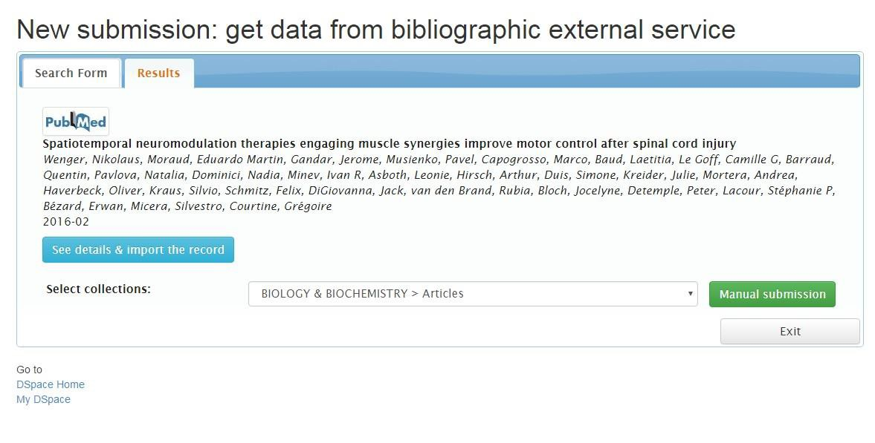
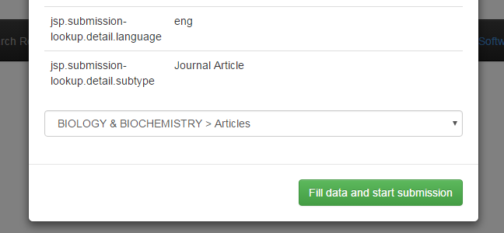
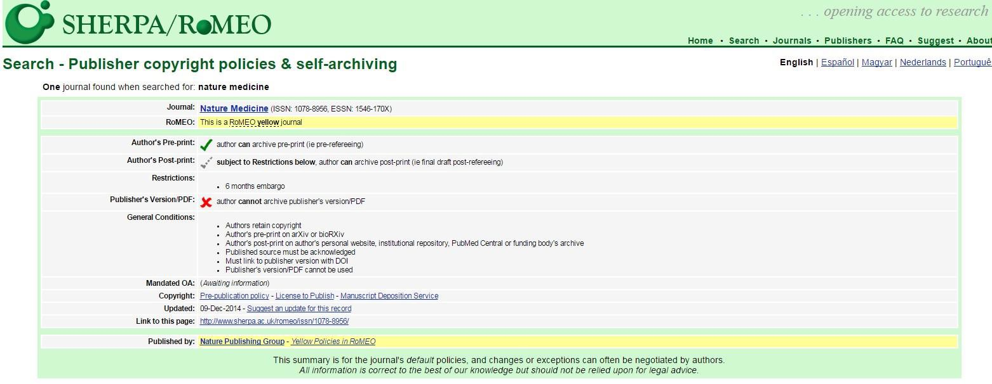

If the information about the publication has been successfully imported, press the “Fill data and start submission” button below the description. This will open a page with partially filled-in publication description fields. Next, you need to fill in the empty fields as described below and upload the full text of the publication in accordance with your publisher policies (pre-print, post-print, etc.).

You should check the policies of the corresponding publisher/journal with regard to placing article texts in the repository at the Sherpa/Romeo website: http://www.sherpa.ac.uk/romeo/index.php.

7

Adding the information includes several steps and consists in filling in the metadata fields. The following progress bar indicates each step in the submission process:

When moving through the process, you can proceed to the next step by clicking on the Next button.

Step 1. Describe

Authors, Title, Type, Language

Authors:

Use this field to enter the information about the last name (surname) and the first name of the author in English (Last name and First name). You can use the First name field to enter the initials (the patronymic name for Russian authors or the middle name or multiple first names for foreign authors).
Example: Иванов Сергей Петрович = Ivanov (Last name), Sergey P. (First Name).
If the publication has several authors, the information about each author is entered separately. You can add more authors by clicking on the Add More button. You can use the Remove Entry button to remove the data. Information about the authors will reflect the order in which the authors were added to the record.

Other Authors:

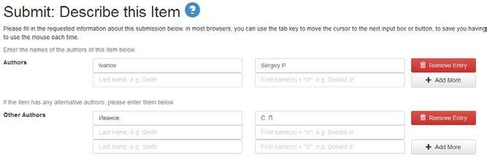
Use this field to enter information about the last name (surname) and the first name of the author in the original language of the publication (Last name and First name). You can add more authors by clicking on the Add More button. You can use the Remove Entry button to remove the data.

Title and Other Titles:

Enter the full name of the document in English in the Title field. Use the Other Titles field to enter the name in the original language of the publication. Use the Remove Entry button to remove the data.
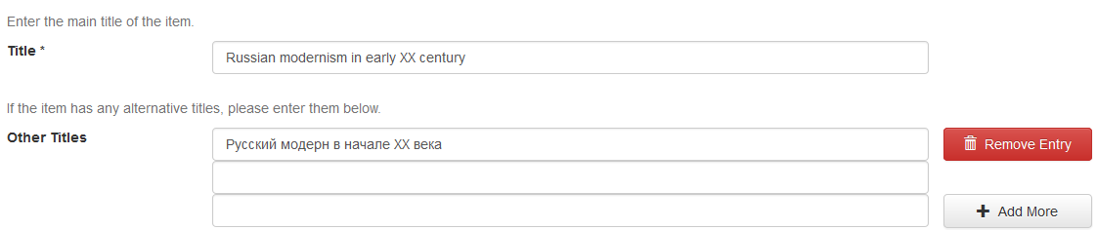
Example: the title Russian modernism in early XX century (Title) = the original title Русский модерн в начале ХХ века (Other Titles).

8

Fields for information about previously published documents:

To enter information about previously published documents, use the following dedicated fields:
- Date of Issue – indicate the year (month and date, if applicable) when the item was published;
- Publisher – enter the name of the publishing organization: the publishing house, the university, the institute, the research institute, etc.);
- Citation – enter citing information for the item, if available (optional).

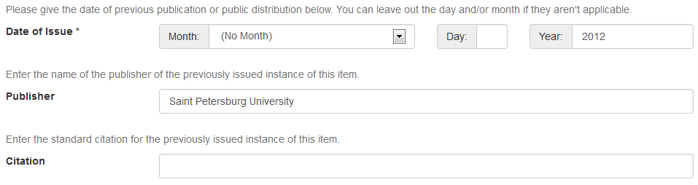

Series/Report No. (Information about a periodical or serial publication):

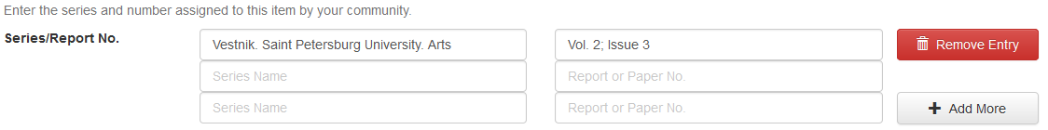
Use the Series Name field to enter the name of the periodical or serial publication where the item was published. Information about the volume number (if applicable) and issue number is entered in the Report or Paper No. input box. You can save the information and create an additional field using the Add More button; use the Remove Entry button to remove the data.

Identifiers:

Select the appropriate type of international identifier or code in the drop down menu:
Gov’t Doc (for an official government document)
ISSN (for a serial publication)
ISBN (for book editions)
ISMN (for printed music)
URI (for an electronic resource on the Internet)
Other (for other types of documents)

After selecting a corresponding identifier, enter the number in the empty input box to the right. If you do not know a unique number or code for your item, you can leave the field empty and not select an identifier. You can save the information and create an additional field using the Add More button; use the Remove Entry button to remove the data.

9

Type:

Select the type of work that best fits your item from the drop down menu in the Type field:
Animation
Article
Book
Book chapter
Dataset
Learning Object
Image
Image, 3D
Map
Musical Score
Plan of blueprint
Preprint
Presentation
Recording, acoustical
Recording, musical
Recording, oral
Software
Technical Report
Thesis
Video
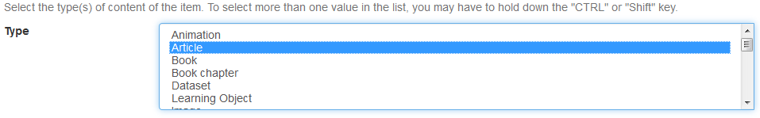
Working Paper
Other

If you want to indicate several types of work at once, you need to select them with the cursor while holding down the Ctrl or Shift key.

Language:

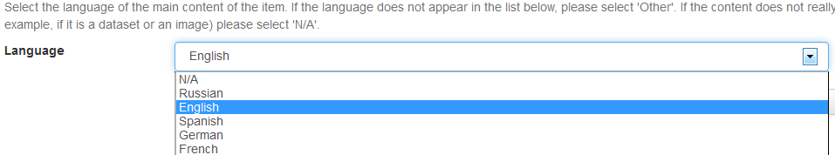
Select the main language of the document from the drop down box. If the required language is not in the list, select the N/A (not available) option.

To navigate between the steps of the submission process, use the following buttons:
Next – click on this button to proceed;
Cancel/Save – click on this button to save the information and leave the submission mode.

Note: please fill in all the required fields marked with an asterisk (*). You can modify the record or add the information to the submission during the editing stage.

Step 2. Describe (continued)

Subject Keywords, Abstract, Alternative Abstract, etc.

Subject Keywords:
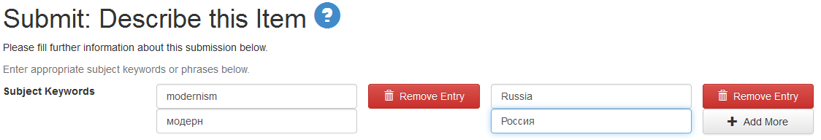
Each separate keyword or keyword phrase should be entered and saved separately, using the Add More button. When you click on the button, a new field appears for entering another keyword. Key words and phrases should be entered consecutively in English and then, if applicable, in the original language of the item. Use the Remove Entry button to remove the data.

Abstract and Alternative Abstract:

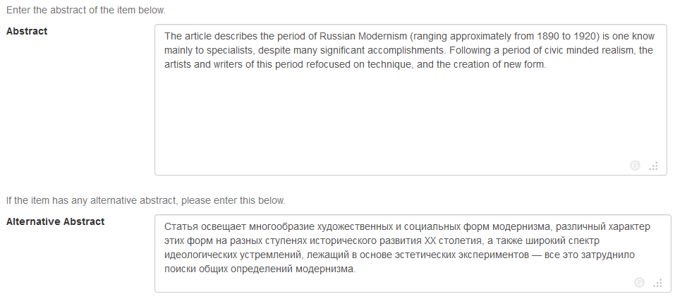
Use the Abstract box to enter the text of the abstract in English. If the item was published in a different language, use the Alternative Abstract box to enter the abstract in the original language of the publication (if available). These fields are optional. You can change the size of the boxes using the arrow in the lower right corner.

11

Other information

If you need to enter additional information about the item, you should do it in English, using the following fields:
- Sponsors – provide the information about the sponsor(s) for your publication here;
- Description – provide any other information describing the item here.

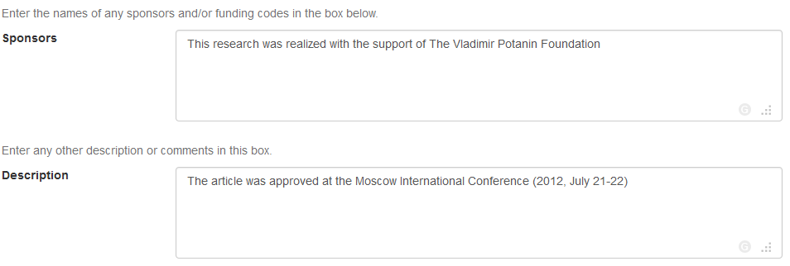

To navigate between the steps of the information submission process, use the following buttons:

Next – click on this button to proceed to the next step;
Cancel/Save – click on this button to save the information and leave the information submission mode;
Previous – click on this button to go back to the previous step.

12

Step 3. Upload a File

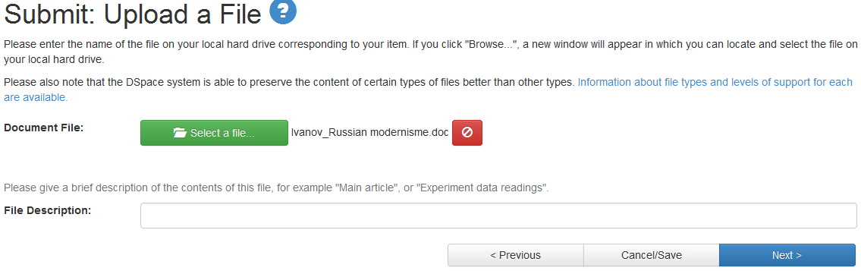
After filling in the main fields, use the “Select a file” button to attach files (the text, pre-print, review, etc.), selecting an appropriate file. Use the File Description field to enter the name of the content (optional).

ATTENTION: Files of published documents can only be uploaded in compliance with the corresponding policies of the publisher or the issuing body.

Attaching a file is a required step in the submission process. If the publisher forbids open distribution of the publication or if a corresponding file is unavailable, you need to attach any file and delete it while editing the record later. Otherwise you will not be able to proceed further.

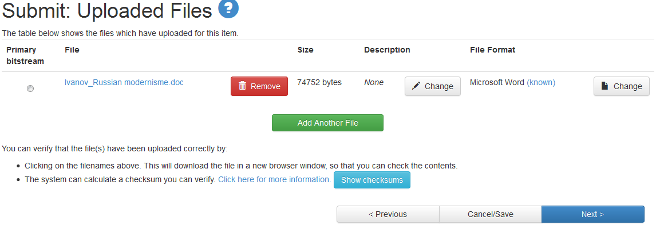
Use the Add Another File button to add several files.

Uploaded files can be deleted or edited, using the Change and Remove Entry buttons.

To navigate between the steps of the submission process, use the following buttons:

Next – click on this button to proceed to the next step;
Cancel/Save – click on this button to save the information and leave the information submission mode;
Previous – click on this button to go back to the previous step.

13

Step 4. Verify Submission

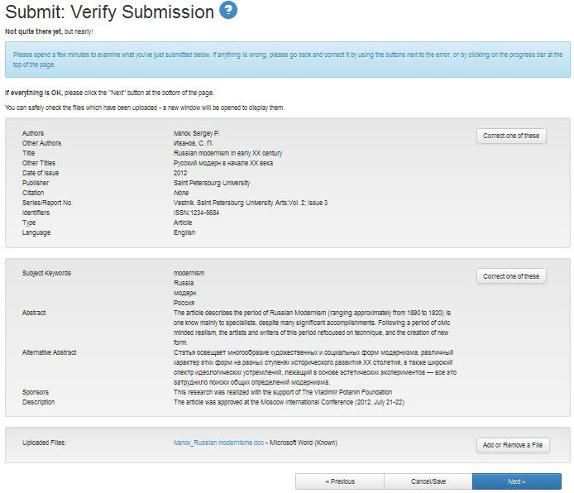
This step lets you review all the information that you have entered and correct it if necessary. The page shows all the previous steps of the submission process. For editing any of the blocks, including replacement of an attached file, use the “Correct one of these” buttons. If you are satisfied that all the information is correct, there is no need to introduce any changes at this point.

To navigate between the steps of the submission process, use the following buttons:

Next – click on this button to proceed to the next step;
Cancel/Save – click on this button to save the information and leave the information submission mode;
Previous – click on this button to go back to the previous step.

14

Step 5. Distribution License

At this stage you are required to confirm your agreement to the terms of the distribution license, using the “I Grant the License” button.
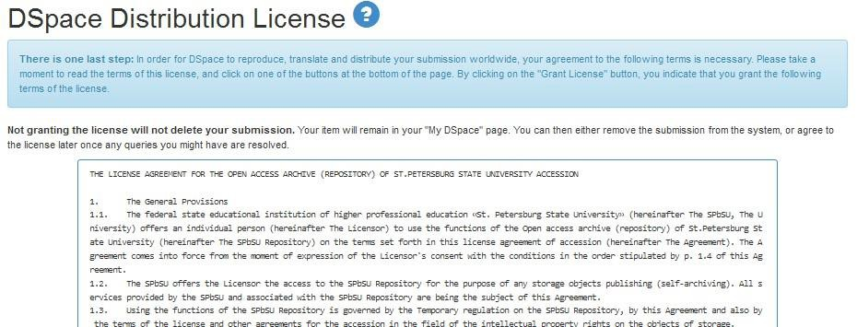
Clicking this button completes the submission process.

If you select the “I Do Not Grant the License” button, the information will be automatically placed on a page that cannot be openly viewed or searched.

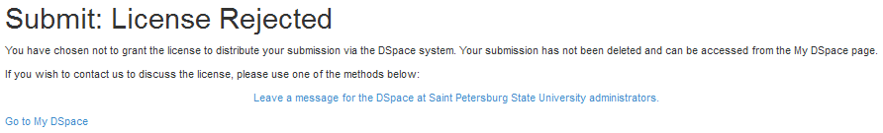
If you have any questions regarding the license, please contact your DSpace administrator, using the “Leave a message…” option.

Step 6. Submission Complete

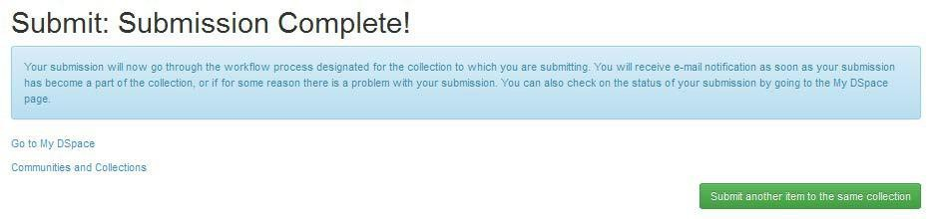
This step means that the record of the item has been placed in the repository.

You will receive an e-mail notification when your submission to the repository is accepted.

15

Additional Information

1. Submitting more items to the repository
If you want to add another submission, click on the “Submit another item to the same collection” button.

2. Checking and editing the record
If you need to edit the submitted information, you should contact the administrator of the repository, using the Feedback service.
3. User access to the new record
All new records are shown on the home page of the repository in the order in which they are added, with the latest submissions visible in the Recent Submissions section.

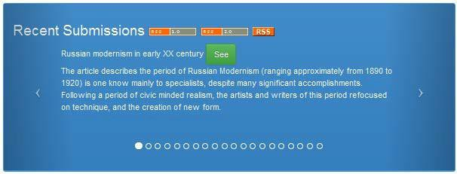
Use the See button to view the simple item record or the full item record, to recommend the publication or to see the viewing figures for the publication.

You can leave your comments on the work of the repository using the feedback form: Feedback.

To receive or restore your login details (login and password), you need to contact members of the technical support staff for subject sections at the IT SPbU or the Technical Support Department at the Rector’s Office, tel.: 326 4990, e-mail: support@spbu.ru.

